Dear Glo,

From every corner of the world, your sisters of 50+1 International stand with you as your city, Westmount, Quebec, heads to the polls. I want to dedicate these words of pride to you, because you are making history as the first person of Latin American origin to run for office — not only in District 7 but in the entire city of Westmount.

I have witnessed your courage in taking this step, a true reflection of the strength of all women who dream of being heard, seen, and represented. The path you have paved not only opens doors for your community, but also inspires many more women to believe that they are already part of the change and decision-making processes abroad.

Your commitment to gender equality and social justice represents exactly the kind of leadership we need to build a more equitable society.

That is the vision of 50+1 International: no matter what the outcome at the polls may be, you already stand as a symbol of courage for us all.

As Founding President of this great collective, I wish you every success in these decisive hours and want you to know that your effort is an inspiration to many.

Today, Quebec votes — and history has already been written in your name, because you have lit a flame that no one will ever be able to extinguish.

With pride and admiration,

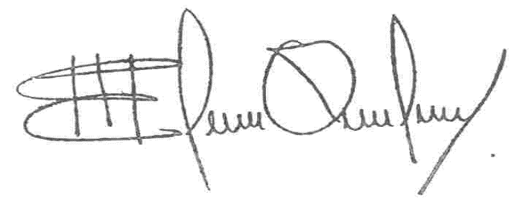

María Elena Orantes
International President, 50+1 Internationale

